Writing Learning Outcomes Worksheet

Program outcomes examine what a program or process is to do, achieve, or accomplish for its own improvement and/or in support of institutional or divisional goals; generally numbers, needs, or satisfaction driven.

Learning outcomes examine cognitive skills that students develop through department interactions; measurable, transferable skill development. They are statements indicating what a participant (usually students) will know, think, or be able to do as a result of an event, activity, program, etc.

ABCD Structure of a Learning Outcome:
- Audience/Who
  - Who does the outcome pertain to?
- Behavior/What
  - What do you expect the audience to know/be able to do? (This needs to include an action verb to describe the learning, chosen from the Bloom’s Taxonomy work bank on page 2.)
- Condition/How
  - Under what conditions or circumstances will the learning occur?
- Degree/How much
  - How much will be accomplished, how well will the behavior need to be performed, and to what level?

Example:

Students who attend advising sessions will choose courses that fulfill their chosen degree requirements.

Outcome Writing – The 3 Ms: Check your outcome against these criteria:
- Meaningful: How does the outcome support the departmental mission or goal?
- Manageable: What is needed to foster the achievement of the outcome? Is the outcome realistic?
- Measurable: How will you know if the outcome is achieved? What is the assessment method?

Initial Problems Encountered When Writing Learning Outcomes:
- Describe program outcomes, rather than learning outcomes
- People don’t use Bloom’s taxonomy verbs and instead use vague terms like: appreciate, become aware of/familiar with, know, learn, value, use, understand…
- Too vast/complex, too wordy
- Multiple outcomes in one learning outcome statement (the word “and” is usually a clue!)
- Not specific enough (e.g., effective communication skills)

Example: To improve this learning outcome statement: “RAs will be more self-aware as leaders”, you could make it:
“As a result of attending RA training, RAs will be able to accurately assess the strengths and weaknesses of their leadership skills.”

Bloom’s Revised Taxonomy Wheel

Utilize this wheel to identify words that describe the behaviors that you are expecting your audience to be able to perform as a result of participation in your program/service. The wheel can also be utilized to identify a method of directly measuring the learning you are trying to capture.

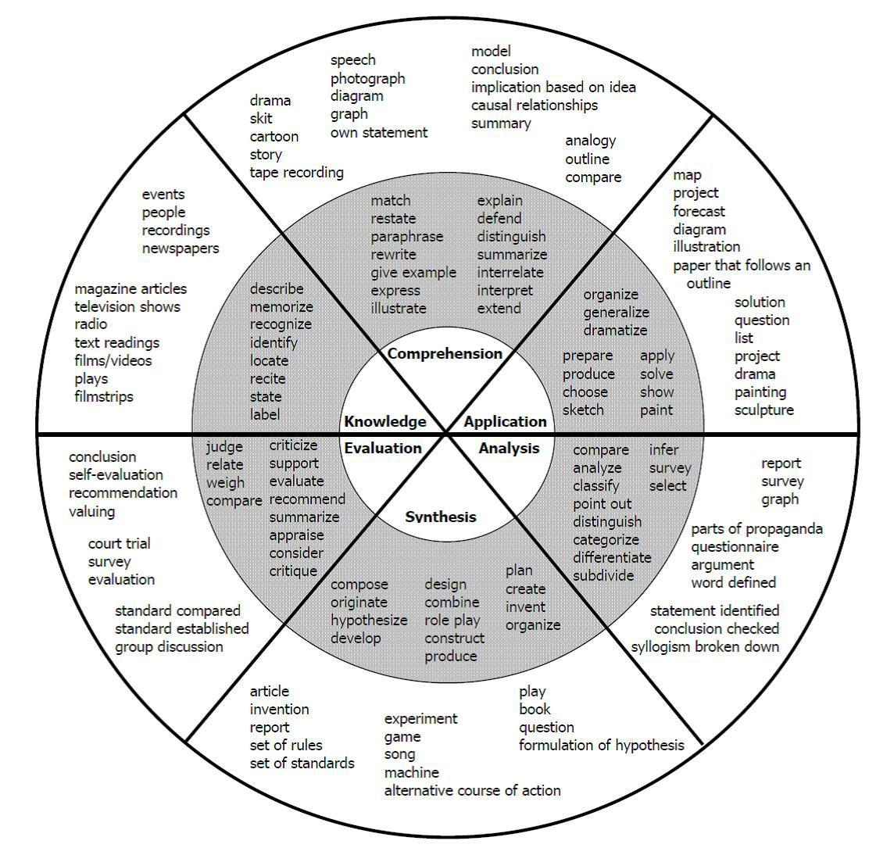
Activity #1: Distinguishing between program and learning outcomes

For each of the statements below, identify…
- Is the statement a program or learning outcome statement?
- What information is missing? How could the outcome be strengthened?

  - The Undergraduate Research Office will increase support for student attendance at regional, national, and international conferences.

  - Students will be able to demonstrate effective communication skills a result of participating in the Leadership Program.

  - The Wellness Program will increase the number of smoking cessation seminars offered by 20% by hiring a graduate assistant to conduct the seminars.

  - Students will identify ten behaviors and/or characteristics of healthy relationships with others after attending this seminar.

  - The number of personal solicitations focused on scholarship needs will increase.

  - Students and faculty will receive more information about co-curricular transcripts and the number of students completing transcripts will increase.

Activity #2: Learning Outcome Components Exercise

For each learning outcome, try to identify the four components:
- Audience/Who
  - Who does the outcome pertain to?
- Behavior/What
  - What do you expect the audience to know/be able to do?
- Condition/How
  - Under what conditions or circumstances will the learning occur?
- Degree/How much
  - How much will be accomplished, how well will the behavior need to be performed, and to what level?

- As a result of attending five counseling sessions at the Student Counseling Center, students will be able to identify one or more strategies to cope with their problems.
Audience: ____________________________________________________________
Behavior: ____________________________________________________________
Condition: ____________________________________________________________
Degree: _______________________________________________________________

- At the conclusion of the Greek Life Anti-Hazing presentation, students in attendance will be able to identify five behaviors or activities that constitute hazing.
Audience: ____________________________________________________________
Behavior: ____________________________________________________________
Condition: ____________________________________________________________
Degree: _______________________________________________________________

- Faculty who attend the NSSE workshop will be able to identify three ways their work contributes to the institution scoring well on the NSSE benchmarks.
Audience: ____________________________________________________________
Behavior: ____________________________________________________________
Condition: ____________________________________________________________
Degree: _______________________________________________________________

Activity #3: Writing Outcomes - practice makes perfect!

Brainstorm…
1. Identify the overarching/broader objective or goal your outcome is going to support:

2. Identify the audience:

3. What do you want them to be able to know, think, or be able to do? (Be specific!)

4. What circumstances or context will foster the learning?

5. To what degree will the learning occur? (Be specific!)

6. How will you measure the learning?

Fill in the blanks:

Audience: ___________________________________________________________________
Behavior: <will learn what>______________________________________________________
Condition: <under these circumstances / conditions> ____________________________________________________________________________
Degree: <to this level of efficiency / effectiveness> ____________________________________________________________________________

Check yourself: Yes No Not sure
Is the outcome measurable?   
Is the outcome meaningful?   
Is the outcome manageable?   
Would you feel comfortable/proud sharing this outcome with   
students, campus constituents, and external audiences?

Rewrite the learning outcome statement to address issues:
____________________________________________________________________________________________________________________________________________________________________________________________________________________________________

Audience: ___________________________________________________________________
Behavior: <will learn what>______________________________________________________
Condition: <under these circumstances / conditions> ____________________________________________________________________________
Degree: <to this level of efficiency / effectiveness> ____________________________________________________________________________

Check yourself: Yes No Not sure
Is the outcome measurable?   
Is the outcome meaningful?   
Is the outcome manageable?   
Would you feel comfortable/proud sharing this outcome with   
students, campus constituents, and external audiences?

Rewrite the learning outcome statement to address issues:
____________________________________________________________________________________________________________________________________________________________________________________________________________________________________

Audience: ___________________________________________________________________
Behavior: <will learn what>______________________________________________________
Condition: <under these circumstances / conditions> ____________________________________________________________________________
Degree: <to this level of efficiency / effectiveness> ____________________________________________________________________________

Check yourself: Yes No Not sure
Is the outcome measurable?   
Is the outcome meaningful?   
Is the outcome manageable?   
Would you feel comfortable/proud sharing this outcome with   
students, campus constituents, and external audiences?

Rewrite the learning outcome statement to address issues:
____________________________________________________________________________________________________________________________________________________________________________________________________________________________________

